3/29/2021

Abdelrahman Adel

Abdelrahman.adel.elsayed@gmail.com

AI Diploma

Assessment One

Contents

Creating Repository: 2

Cloning the Repository: 3

# Creating Repository:

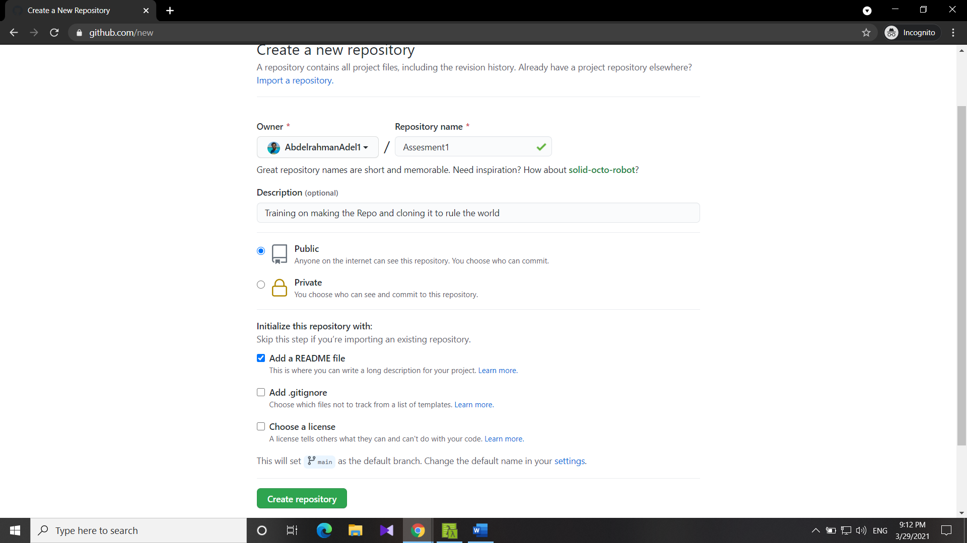

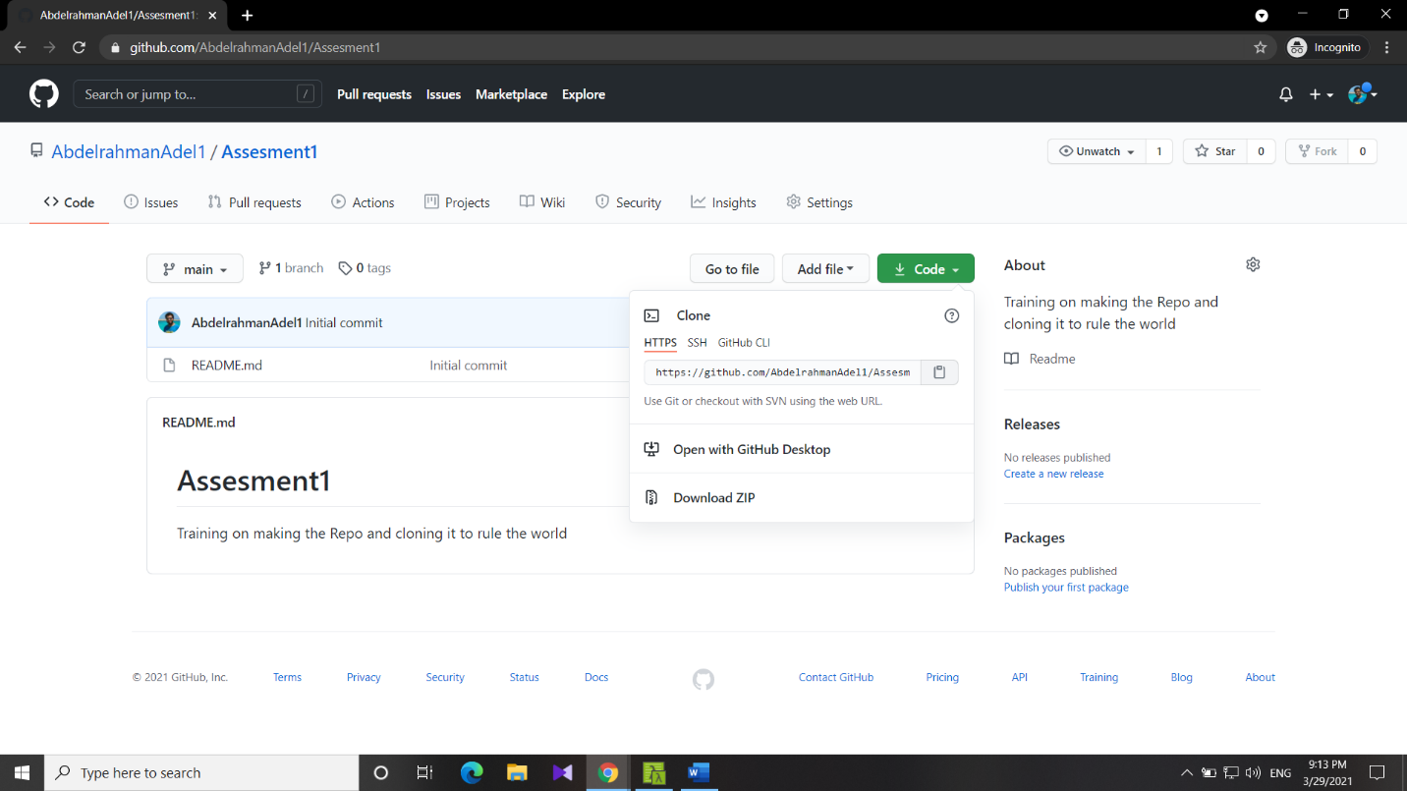

# Cloning the Repository:

